**File handling**

It is a process of opening, reading, writing , updating and deleting the text file.

**Create a file**

f=open('umesh.txt','x')

**Adding an text in the file.**

f=open('umesh.txt','w')

f.write(‘Umesh Indra Mandati is from Khammam’)

f.close()

**If you want to add the next the text means**

f=open('umesh.txt','a')

f.write(‘we are the interns of puropale’)

f.close()

**if you want the extract what text inside is**

f=open('umesh.txt','r')

f.read()

**if you want to extract the specific text from the entire text means**

f=open('umesh.txt','r')

f.readline(5)

f.close()

# If you use multiple readline it gives the next new line

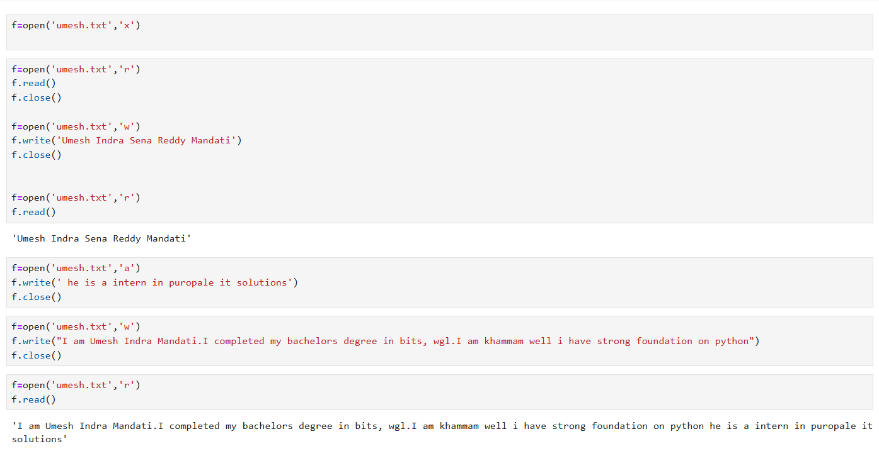

Remove the text file

Import os

Os.remove(‘umesh.txt’)

#succesfully the file is removed

Where

r used for read mode

w used for write mode

a used for append mode

x used for creating mode